**Figure 1:** Test of Overlap Assumption for Causal forests

* 1. Reading Score

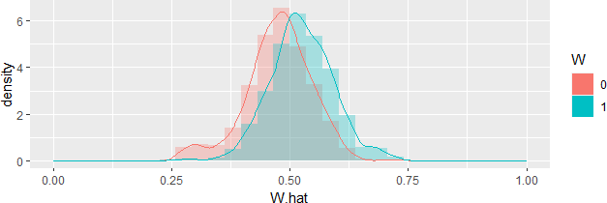

* 1. Math Score

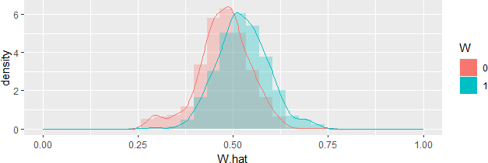

Note: In the figures above, ‘W.hat’ refers to the propensity scores. The propensity scores are learned via GRF’s regression forest.

**Figure 2:** Histogram of out-of-bag CATT estimates from Causal forests

1. Reading Score

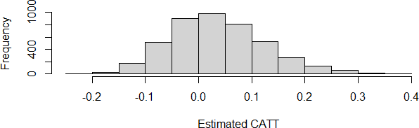

1. Math Score

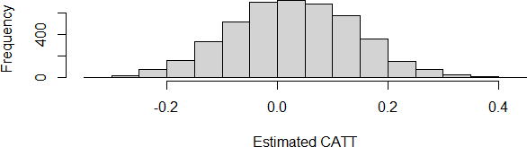

**Table 1:** Best Linear Projection (BLP) of CATT estimates

Variables Reading Score Math Score

|  |  |
| --- | --- |
| Child’s age -0.013 | 0.021 |
| (0.025) | (0.025) |
| Child's sex (male=0, female=1) 0.112** | 0.090* |
| (0.053) | (0.053) |
| Child's family type (nuclear=0, joint=1) 0.077 | 0.098 |
| (0.066) | (0.066) |
| Mother's age 0.001 | -0.003 |
| (0.007) | (0.007) |
| Mother's education (years completed) -0.007 | -0.013 |
| (0.008) | (0.008) |
| Mother's health (poor=0, good=1) 0.129 | 0.057 |
| (0.156) | (0.153) |
| Number of surviving children -0.008 | 0.017 |
| (0.027) | (0.027) |
| Father's education (years completed) 0.002 | 0.007 |
| (0.008) | (0.008) |
| Child's teacher is regular 0.067 | 0.168 |
| (0.140) | (0.140) |
| Child's teacher is good -0.325** | -0.370*** |
| (0.151) | (0.127) |
| Child receives mid-day meals -0.152* | -0.200** |
| (0.090) | (0.092) |
| Water available in household 0.146 | 0.136 |
| (0.101) | (0.097) |
| Toilet available in household -0.056 | -0.001 |
| (0.069) | (0.075) |
| Electricity available in household -0.101 | -0.081 |
| (0.073) | (0.070) |
| Number of meals per day in household -0.048 | -0.057 |
| (0.041) | (0.041) |
| Household's residence (rural=0, urban=1) -0.195** | -0.231*** |
| (0.085) | (0.085) |
| Household is below poverty line -0.049 | -0.017 |
| (0.076) | (0.075) |
| Log of household's annual consumption expenditure -0.101 | -0.103 |
| (0.076) | (0.075) |
| Child's school type (public=1, private=2, other=3) -0.048 | -0.025 |
| (0.089) | (0.089) |
| Household’s economic status 0.051 | -0.029 |
| (0.088) | (0.088) |
| Household's caste (forward caste=1, obc=2, dalit=3, 0.069 | 0.019 |
| other=4) (0.054) | (0.054) |
| Household's religion (hindu=1, muslim=2, 0.004 | 0.106 |
| christian=3, other=4) (0.093) | (0.093) |

Note: *p<0.1; **p<0.05; ***p<0.01

Best Linear Projection of CATT provides a more expressive summary of the CATT function using the doubly robust AIPW estimator. The coefficients above show the association of the CATT function with the covariates. If the coefficients of the covariates are statistically significant there is a very high likelihood that there is heterogeneity along these covariates. However, if the coefficients are not statistically significant, it does not directly imply that there is no heterogeneity along these covariates.